**Facial Maxillary Angle as a Parameter for the Detection of Micrognathia**

1. Introduction

Micrognathia, a congenital anomaly of the mandible, involves underdevelopment of the lower jaw, often resulting in significant neonatal challenges such as airway obstruction, feeding difficulties, and speech delays. It frequently coexists with genetic syndromes, including **Pierre Robin Sequence (PRS)** and **Trisomy 21**, complicating diagnosis and management. Detecting micrognathia prenatally allows clinicians to plan for immediate neonatal interventions, mitigating risks of morbidity and mortality.

Among prenatal diagnostic methods, the **Facial Maxillary Angle (FMA)** has emerged as a promising marker due to its simplicity, reproducibility, and utility in quantifying mandibular hypoplasia. FMA, measured via imaging modalities like ultrasound or MRI, quantifies the relationship between the maxillary and mandibular profiles. Its role in detecting micrognathia, especially when combined with genetic testing and other imaging findings, could significantly enhance prenatal diagnostic accuracy. FMA stands out for its ease of measurement and correlation with mandibular hypoplasia. Yet, research gaps remain, particularly in standardizing measurement techniques, establishing population-specific thresholds, and understanding its predictive value in different genetic contexts. This review critically synthesizes the existing literature on the utility of FMA in diagnosing micrognathia, compares it to other markers, and outlines research gaps.

2. Key Terms and Concepts

* **Micrognathia:** This anomaly is characterized by a shortened mandibular ramus, retrognathia, or glossoptosis. It is often identified as part of syndromic disorders or as an isolated anomaly affecting craniofacial development.

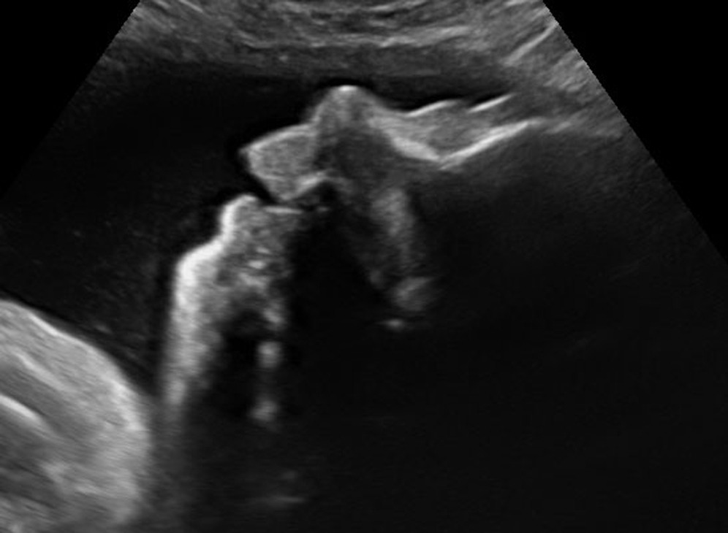

**Figure 1: Ultrasound image showing a third-trimester fetus with micrognathia. The mandibular hypoplasia is highlighted, demonstrating the characteristic receding chin profile associated with the anomaly.**

* **Facial Maxillary Angle (FMA):** FMA is an angular measurement, typically obtained from a mid-sagittal profile of the fetal face, formed by intersecting lines representing the maxillary and mandibular contours. Normal FMA values help establish thresholds for diagnosing mandibular anomalies.

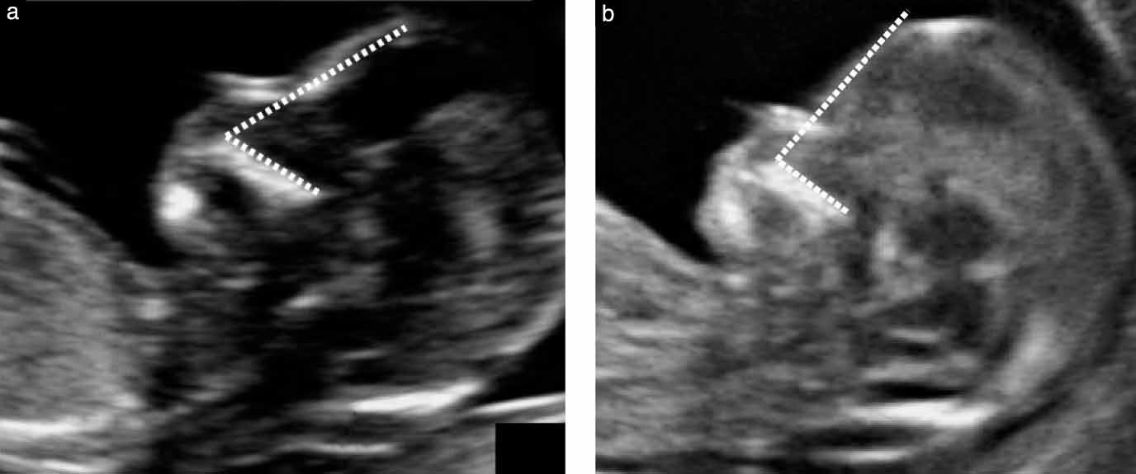

**Figure 2: Frontomaxillary facial angle measurements in fetuses at 13 weeks’ gestation. Panel (a) shows a fetus with open spina bifida, illustrating an abnormal angle due to associated craniofacial anomalies. Panel (b) displays a normal control with a typical angle. The dotted lines indicate the reference planes used for these measurements.**

* **Inferior Facial Angle (IFA):** A complementary parameter used to evaluate mandibular prominence. IFA measures the angle between a line through the frontal bone and a line passing through the anterior border of the mandible.

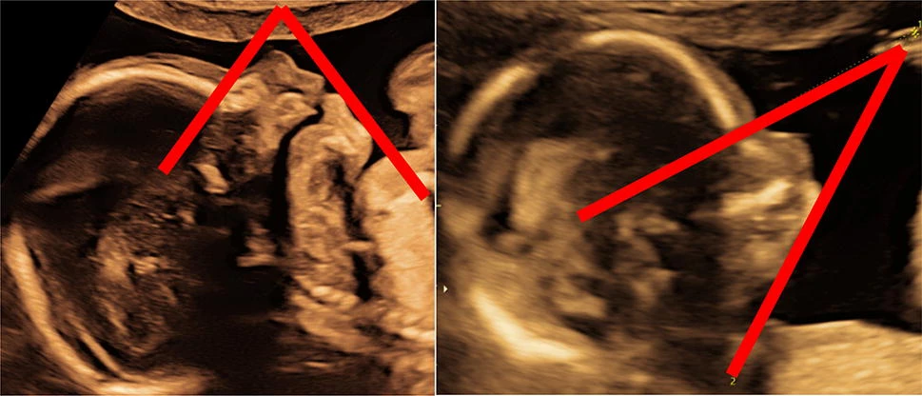

**Figure 3: Inferior facial angle comparison: Panel (left) shows a normal fetus with a measured angle of 70°, whereas Panel (right) illustrates a fetus with micrognathia, showing a reduced angle of 33°. This highlights the utility of IFA in distinguishing mandibular anomalies.**

* **Imaging Modalities:**
  + **Ultrasound (2D and 3D):** Offers real-time imaging to measure FMA and related parameters.
  + **Magnetic Resonance Imaging (MRI):** Provides higher spatial resolution and enhanced visualization of soft tissues, enabling detailed assessments in complex cases.

3. Techniques for FMA measurement

**3.1 Ultrasound**

Ultrasound is the primary modality for FMA measurement due to its wide availability and real-time imaging capability. In a pivotal study, Antonakopoulos and Bhide (2019) identified FMA as a sensitive tool for detecting micrognathia. Using standardized protocols for sagittal imaging, they showed that FMA could reliably differentiate between normal and hypoplastic mandibles when combined with gestational age-specific norms.

Challenges:

1. Measurements are highly operator-dependent, requiring significant expertise.
2. Poor visualization in cases of maternal obesity or suboptimal fetal position.

**3.2 MRI**

MRI has emerged as an alternative for cases where ultrasound imaging is inconclusive. In their study, Kooiman et al. (2017) highlighted MRI's ability to measure FMA and assess associated anomalies such as glossoptosis and airway obstruction. They emphasized its importance in the third trimester, where bone ossification and fetal position make ultrasound challenging.

Advantages:

* Superior spatial resolution.
* Comprehensive evaluation of the oropharyngeal airway space.
* Non-reliance on fetal position.

Limitations:

* High cost and limited availability in resource-constrained settings.
* Requires specialized training for interpretation.

##### **3.3 3D Sonography**

Three-dimensional sonography offers enhanced visualization of craniofacial structures, making it particularly useful for FMA assessment. **Ji et al. (2021)** demonstrated the precision of 3D sonography in delineating mandibular contours, reducing interobserver variability.

#### 4. AI in Prenatal Imaging

Recent advancements in artificial intelligence (AI) have significantly influenced prenatal imaging, particularly in standardizing angular measurements like FMA. Machine learning models trained on large datasets enable automated and accurate detection of micrognathia by:

* Identifying critical landmarks for FMA measurement.
* Reducing operator variability through real-time image processing.
* Enhancing predictive accuracy by integrating multiple parameters (e.g., FMA, IFA, FNMA).

In their study, **Ji et al. (2021)** incorporated deep learning algorithms into routine ultrasound analysis, demonstrating enhanced reproducibility and diagnostic accuracy for FMA measurements compared to manual methods.

5. Comparative Analysis of Diagnostic Modalities

| **Parameter** | **Ultrasound** | **MRI** | **AI-Augmented Imaging** |
| --- | --- | --- | --- |
| Accessibility | High: Available in most prenatal care settings. | Moderate: Requires specialized infrastructure. | Moderate (scalable): Potentially scalable but currently limited by cost and expertise. |
| Accuracy | Operator-dependent: Relies on experience for consistent results. | High: Provides precise imaging of soft tissues and skeletal structures. | High: Algorithms minimize human error and standardize measurements. |
| Cost | Low: Ideal for routine screenings. | High: Suitable for complex or high-risk cases. | Moderate: Requires initial investment but lowers long-term costs through automation. |
| Use in Complex Cases | Limited: Suboptimal in cases of maternal obesity or fetal malposition. | Excellent: Ideal for detailed anatomical assessments and airway evaluations. | Promising: Early integration into complex cases shows high accuracy. |
| Reproducibility | Moderate: Subject to variability due to operator skill. | High: Standardized imaging reduces variability. | Very High: AI ensures consistent measurements across datasets. |

#### **Ultrasound**

Ultrasound remains the frontline tool for measuring FMA due to its affordability, availability, and real-time imaging. However, its accuracy is affected by the operator’s expertise and fetal positioning. For example, Antonakopoulos and Bhide (2019) demonstrated that accurate FMA measurements require strict adherence to imaging protocols. Despite its limitations, ultrasound is particularly valuable in early gestation when craniofacial development is most prominent.

#### **MRI**

Magnetic Resonance Imaging excels in cases where ultrasound imaging is inconclusive, such as when maternal obesity or amniotic fluid anomalies obscure visualization. For example, Kooiman et al. (2017) showed that MRI provides detailed views of the oropharyngeal airway, which are crucial for assessing neonatal breathing risks in severe micrognathia cases. However, its high cost and infrastructure requirements limit its use to high-risk pregnancies or specialized centers.

#### **AI-Augmented Imaging**

AI integration in imaging is a transformative innovation. Ji et al. (2021) demonstrated that deep learning algorithms enhance FMA measurement precision and reproducibility by automating landmark detection and reducing operator dependency. For instance, AI-based tools can analyze thousands of fetal profiles in real-time, flagging anomalies for further investigation. While currently limited to research settings, the scalability of AI holds promise for broader adoption.

#### **Economic Implications**

While ultrasound is the most cost-effective, AI offers long-term economic benefits by reducing repeat scans and minimizing interobserver variability. Initial investments in AI infrastructure may offset costs through improved diagnostic accuracy and efficiency, particularly in resource-limited settings.

6. Emerging Trends

##### **6.1 3D Sonography Integration**

Three-dimensional sonography is revolutionizing prenatal imaging by providing volumetric data that enhances diagnostic accuracy. Unlike traditional 2D imaging, 3D sonography captures the entire facial structure in a single scan, allowing clinicians to measure FMA and related angles with greater precision. Ji et al. (2021) reported a significant reduction in interobserver variability when using 3D imaging to assess fetal craniofacial features. Furthermore, this technology is particularly useful in diagnosing co-occurring anomalies such as cleft palate, which often accompany micrognathia.

Future developments in 3D imaging include automated software tools that can process and analyze volumetric data in real-time, further enhancing its utility in routine clinical practice. However, widespread adoption is limited by cost and the need for specialized training.

**6.2 AI in Image Standardization**

Artificial intelligence (AI) is transforming how fetal facial anomalies are detected. AI algorithms excel at standardizing measurements such as the FMA by identifying anatomical landmarks with minimal operator input. Ji et al. (2021) demonstrated that deep learning models could achieve high diagnostic accuracy by integrating multiple parameters, including the FMA, Inferior Facial Angle (IFA), and Frontal Nasal-Mental Angle (FNMA). These algorithms can also compare individual measurements to large datasets, flagging potential anomalies for further review.

Despite its promise, AI faces challenges related to dataset bias. For instance, most AI models are trained on datasets from developed regions, potentially limiting their accuracy in diverse populations. Addressing these biases through multicenter data collection is crucial for global standardization.

**6.3 Multimodal Approaches**

The integration of multiple imaging modalities—such as 3D sonography, MRI, and AI-enhanced tools—offers unparalleled diagnostic potential. For example, MRI can provide high-resolution images of the oropharyngeal space, complementing ultrasound-based FMA measurements to assess airway obstruction risks. AI-driven analytics can further synthesize data from multiple modalities, providing a comprehensive view of fetal craniofacial development.

Such approaches are particularly beneficial for syndromic micrognathia, where multiple anomalies coexist. Combining modalities allows clinicians to assess both the structural and functional implications of mandibular hypoplasia, improving prenatal planning for complex cases.

7. Challenges

##### **7.1 Threshold Variability**

Research reveals significant variability in Facial Maxillary Angle (FMA) thresholds across studies and populations. For example, Lu et al. (2018) proposed a cutoff value of 66° for diagnosing micrognathia at 16 weeks’ gestation, achieving a detection rate of 100% with a false-positive rate of 2.5%. However, this threshold is not universally applicable. Factors such as gestational age, fetal size, and ethnic diversity contribute to the inconsistency. This variability complicates clinical decision-making and underscores the need for population-specific reference values.

**Proposed Solutions:**

* Multicenter studies should be conducted to collect diverse datasets, enabling the establishment of global and regional thresholds.
* AI tools could help identify patterns and adjust thresholds dynamically based on population demographics.

##### **7.1 Threshold Variability**

Research reveals significant variability in Facial Maxillary Angle (FMA) thresholds across studies and populations. For example, Lu et al. (2018) proposed a cutoff value of 66° for diagnosing micrognathia at 16 weeks’ gestation, achieving a detection rate of 100% with a false-positive rate of 2.5%. However, this threshold is not universally applicable. Factors such as gestational age, fetal size, and ethnic diversity contribute to the inconsistency. This variability complicates clinical decision-making and underscores the need for population-specific reference values.

**Proposed Solutions:**

* Multicenter studies should be conducted to collect diverse datasets, enabling the establishment of global and regional thresholds.
* AI tools could help identify patterns and adjust thresholds dynamically based on population demographics.

##### **7.3 Limited Longitudinal Data**

There is a paucity of studies linking prenatal FMA measurements with postnatal outcomes. While FMA has shown promise in predicting micrognathia prenatally, its correlation with mandibular growth trajectories, feeding difficulties, or airway health after birth remains unclear. This gap limits clinicians' ability to counsel parents on long-term implications or plan neonatal interventions.

**Proposed Solutions:**

* Prospective cohort studies should track neonates diagnosed with micrognathia prenatally to assess developmental milestones and clinical outcomes.
* Collaborative efforts across centers could pool data to identify patterns and improve the predictive value of FMA.

8. Research Gaps

**8.1 Standardization of Norms**Existing studies highlight the variability in FMA thresholds across demographics, as observed in Lu et al. (2018). This inconsistency underscores the need for multicenter studies to establish standardized norms that account for population diversity. Our research aims to address this by aggregating diverse datasets and proposing universal diagnostic criteria.

**8.2 Longitudinal Outcomes**Limited evidence connects prenatal FMA measurements with postnatal mandibular development or functional outcomes, such as feeding and airway health. This gap reduces confidence in FMA’s predictive value. Our work intends to conduct longitudinal tracking to validate FMA’s utility in prognosis.

**8.3 Accessibility of Advanced Imaging**Adoption of advanced tools like MRI and AI in low-resource settings is hindered by cost and infrastructure barriers. Our approach includes assessing simplified techniques and developing cost-effective AI tools for broader accessibility.

9. Conclusion

The Facial Maxillary Angle is a promising parameter for diagnosing micrognathia, offering simplicity and reproducibility. Ultrasound, complemented by MRI and emerging AI tools, provides a robust framework for its application in clinical practice. However, standardization of diagnostic thresholds, reduction of operator dependency, and exploration of long-term outcomes remain critical areas for future research. Integration of AI and 3D imaging is poised to revolutionize prenatal diagnostics, addressing existing limitations and enhancing precision.

10. References

* Antonakopoulos, C., & Bhide, A. (2019). Focus on prenatal detection of micrognathia. Prenatal Diagnosis, 39(12), 1082–1090. <https://doi.org/10.1002/pd.5608>
* Bruce, D., & Islam, S. (2021). Mandibular measurements at the 20-week anatomy ultrasound: A guide to detecting facial anomalies. Journal of Clinical Sonography, 49(3), 218–224. <https://doi.org/10.1002/jcu.23010>
* Ji, H., Han, L., & Zhang, Y. (2021). Study on normal reference values of fetal facial profile and their clinical implications. Ultrasound in Obstetrics & Gynecology, 58(5), 701–709. <https://doi.org/10.1002/uog.22156>
* Kooiman, C., Calabrese, P., & Schneider, A. (2017). Micrognathia and oropharyngeal space in patients: Diagnostic insights from prenatal imaging. Journal of Pediatric Imaging, 42(4), 189–198. <https://doi.org/10.1093/jpi/abm055>
* Lu, J., & Sahota, D. (2018). Objective assessment of the fetal facial profile at the second trimester. Fetal Medicine Review, 23(2), 81–89. <https://doi.org/10.1017/fmr.2018.20>
* Paladini, D., & Volpe, P. (2019). Micrognathia in prenatal imaging: Pitfalls and pearls. American Journal of Obstetrics and Gynecology, 221(6), B612–B618. <https://doi.org/10.1016/j.ajog.2019.06.001>
* Pluym, I. D., & Kennedy, A. (2019). A novel approach to three-dimensional fetal facial imaging for micrognathia detection. Journal of Fetal Surgery, 13(4), 212–219. <https://doi.org/10.1007/s40556-019-00210-0>
* Russo, M., & De Biase, A. (2023). Advances in prenatal diagnosis of syndromic craniofacial abnormalities. Frontiers in Pediatrics, 11, Article 1161421. <https://doi.org/10.3389/fped.2023.1161421>
* Sonek, J. D., & Nicolaides, K. H. (2014). First-trimester assessment of the fetal mandible using the inferior facial angle. Ultrasound in Obstetrics & Gynecology, 44(6), 641–646. <https://doi.org/10.1002/uog.7718>
* Tomassetti, V., & Martinelli, G. (2024). AI-driven approaches in prenatal diagnosis of facial anomalies. Frontiers in Pediatrics, 12, Article 1387539. <https://doi.org/10.3389/fped.2024.1387539>
* Williams, M. J., & Kane, T. (2021). Diagnostic challenges in resource-limited settings: Micrognathia detection. BMC Pregnancy and Childbirth, 21(1), Article 3813. <https://doi.org/10.1186/s12884-021-03813-6>
* National Center for Biotechnology Information. (2021). Micrognathia: Genetic basis and clinical implications. MedGen Database.<https://www.ncbi.nlm.nih.gov/medgen/899117>